**Project Assignment No-2**

**Project Name-Elevations Credit Union**

**IST 647**

**Group Members-**

Swapnil Nikam (006706772)

Digvijay Singh (005791834)

Mohammed Saad (006712128)

Shubhankar Jathar (006704614)

1.External Database Model

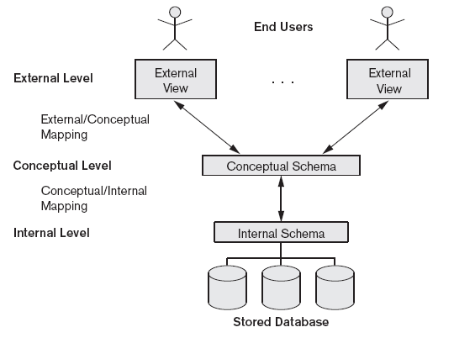



2. Conceptual/Logical database model



3.Organization Structure view

